HermanosF,{08da2a22-0d4f-4928-b161-45e8715d0d1a}{34},3.1875,2.875Unidos

**Where it all began**

F,{08da2a22-0d4f-4928-b161-45e8715d0d1a}{45},5.604167,3.333333

Hermanos Unidos was created in 1989 at the University of California, Berkeley with founding members Angel Ortiz, Eddie Duque, George Alva and Isaias Martinez. Creating the group Hermanos Unidos allowed members to have a “familia” away from home. The name for this non-profit organization was created to remind each Chicano and Latino the reason’s why they are getting a higher education. Members have been able to relate with one another through experiences. Familias are centered towards creating a powerful and sensitive hermandad towards other Hispanic, Latino and Mexican cultures. Each familia must follow the three pillars set into the mission statement; community service, academic and social networking. These pillars allow each member break sterotypes placed by society in creating “El Nuevo Hombre.”

**Hermanos Unidos de Long Beach**

F,{08da2a22-0d4f-4928-b161-45e8715d0d1a}{56},7.541667,4.3125

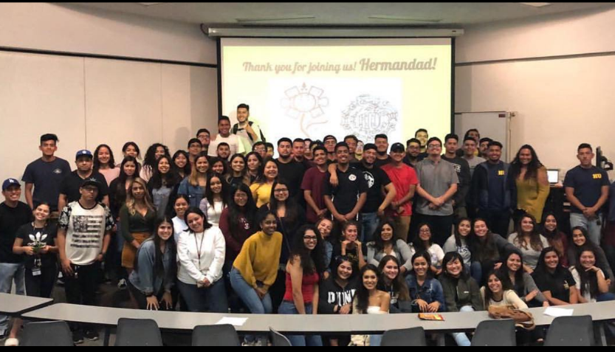

Created in 2008 Hermanos Unidos de Long Beach, allowing the student body of California State University, Long Beach make connections with students have similar backgrounds. Creating a safe space for any individual; regardless of race, ethnicity, color or cultural background. Hermanos Unidos is to help any individual on-campus at CSULB to find a space where they can openly express themselves. HU de Long Beach follows the three pillars to makes sure the original mission of HU as a whole organization is still going being enforced. “El Nuevo Hombre” is the second goal the organization wants to pursue. Changing the way Hispanics are seen through the public eye and slowly taking down the stereotypes placed on masculinity.

**Community Service**

F,{08da2a22-0d4f-4928-b161-45e8715d0d1a}{77},3.4375,5.145833

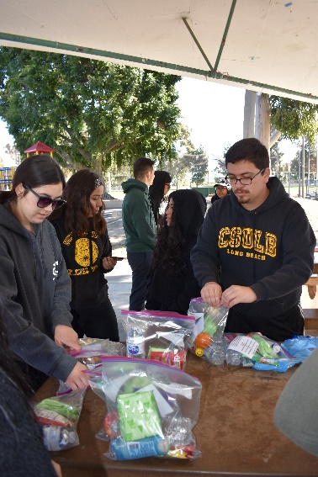

From the beginning of HU the founding members made it a priority for the members to give back to the community. Giving back to the community is one of the three pillars Hermanos Unidos is funded on. Balancing each pillar evenly is important, to ensure the “Nuevo Hombre” is being implemented by all members. Community service allows members to give back to their communities and to those who are less fortunate than they are. HU takes part in helping the homeless around their communities, this event is called “Brown Bags.” Typically, other familias help out by donating sanitary products, food and clothing.

**Academic**

F,{08da2a22-0d4f-4928-b161-45e8715d0d1a}{96},3.25,3.25

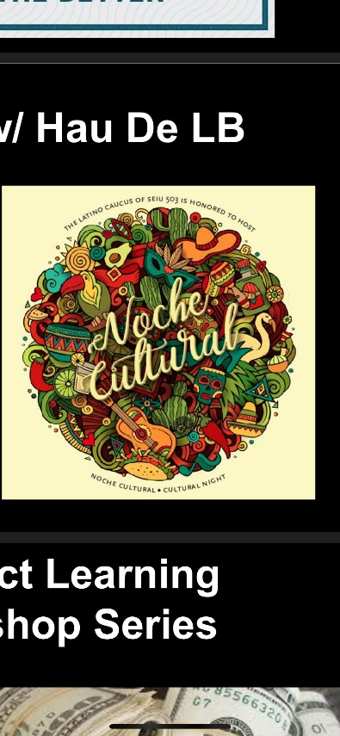

The second pillar of Hermanos Unidos in creating the “Nuevo Hombre” is succeeding academically. Supporting members through their academic journey at CSULB is very important especially in changing how society views Latinos and Hispanics. Hosting study halls, visits to museums and workshops that will help members in the future, such as FASFA workshops, awareness of resources on campus and internship opportunities. Collaborating with other familias on other academic events allows the unity between the entire organization as a whole throughout the state of California.

**Social Networking**

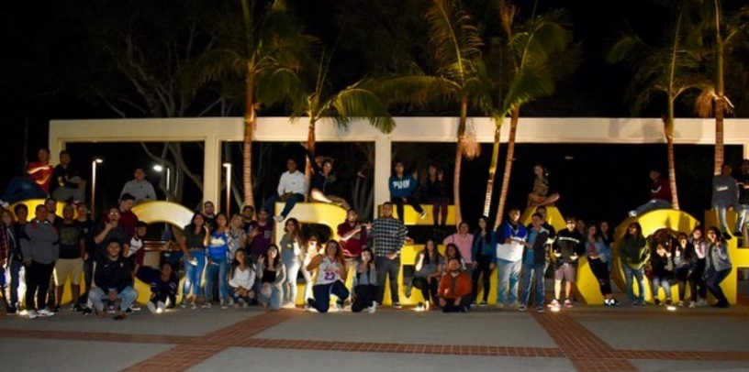

The last pillar that is supported by Hermanos Unidos is social networking, this allows members across the state help one another get connections and jobs for the future.

**National Leadership Conference**

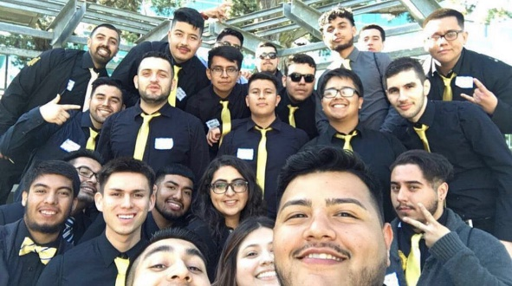

The first National Leadership Conference was held on 2001-2002